# **USD SWAP TRADING**

Jackie Li ([firenze1909@gmail.com](mailto:firenze1909@gmail.com))

I. SOFR Curve Construction 2

1. Assumptions 3

2. Market Instruments 3

3. Front End Curve 4

4. 3y+ Curve Residual control 5

II. Trading Ideas 6

1. 5s10s30s Swap Fly 6

2. Short 10y Spread. 8

3. SR3 vs SR1 Futures 9

III. What I Need 10

## SOFR Curve Construction

I have built the SOFR curve as of closing 8/25/2023. The accuracy to Bloomberg benchmark is always within 0.02bp. The library is written in Python, using datasets from Bloomberg.

See below the overnight forward curve and the par swap yield curve.

### Assumptions

My focus in on the overnight forward curve backboned upon SOFR Index, which can easily transfer to par swap rate curve. The initial date is set to be 8/25/2023, settlement is 8/27/2023.

* Using the SR3 futures in the front end (<3yrs), adjusted by convexity.
* Using Swap rates for 3+ tenor, first layer is 5y, 7y, 10y, 15y, 20y, 30y, 40y and 50y. and implemented the skewness adjustment for 4y, 6y, 8y, 9y, 12y, 25y, 35y and 45y, which are the second layer. In practice, I would implement 3 layers:
  + First layer: Cash yield on (5y, 10y, 30y) + corresponding swap spreads
  + Second layer: 4y, 7y, 15y, 20y
  + Third layer: 6y, 8y, 9y, 11y, 12y, 25y, 40y, 50y
* Using Log-linear interpolation on DF for front end, and log-cubic spline interpolation for 3+ tenor.
* The curve is solved by auto-differentiation under Dual number. Levenberg-Marquardt method is used to blend both the gradient descent and Gauss-Newton method.
* No turns, no holidays and no business day convention for simplicity.
* Knots are placed at strategic points as IMM dates, rather than at the maturity of par tenor. instruments. This is to avoid large exchange basis and carry fluctuation when market advanced.

### Market Instruments



### Front End Curve

Here we zoomed in to have a better view on the front end curve. For up to 3y, we have

The nodes are placed at FOMC meeting dates.

Note that the future convexity adjustment is based on the following 2 papers.

* [Hull. 2002. Options, Future and Other Derivatives](https://rads.stackoverflow.com/amzn/click/com/B01K94T4CG) p. 566.
* [Piterbarg and Renedo. 2006. Eurodollar Futures Convexity Adjustments in Stochastic Volalitiy Model. 2006](https://www.risk.net/journal-of-computational-finance/2160379/eurodollar-futures-convexity-adjustments-in-stochastic-volatility-models)

The mean reversion speed is set to be 0.03 and rate vol is set to be 140bps. The closing for SFRM5 is 96.075, so if you look at *SFRM5C 96.0000 COMB Comdty,* this serial option has implied volatility at 37.188% which at current rates (3.925%) is around 140bps.

|  |  |  |  |  |
| --- | --- | --- | --- | --- |
| **Start Date** | **Days** | **Ticker** | **Last** | **Implied Forward** |
| 08/30/2023 | 21 | SFRM3 | 94.6847 | 5.3153 |
| 09/20/2023 | 91 | SFRU3 | 94.545 | 5.4543 |
| 12/20/2023 | 91 | SFRZ3 | 94.51 | 5.4868 |
| 03/20/2024 | 91 | SFRH4 | 94.645 | 5.3482 |
| 06/19/2024 | 91 | SFRM4 | 94.925 | 5.0634 |
| 09/18/2024 | 91 | SFRU4 | 95.295 | 4.6874 |
| 12/18/2024 | 91 | SFRZ4 | 95.645 | 4.3304 |
| 03/19/2025 | 91 | SFRH5 | 95.91 | 4.0572 |
| 06/18/2025 | 91 | SFRM5 | 96.075 | 3.883 |
| 09/17/2025 | 91 | SFRU5 | 96.16 | 3.7877 |
| 12/17/2025 | 91 | SFRZ5 | 96.195 | 3.7414 |
| 03/18/2026 | 91 | SFRH6 | 96.215 | 3.7092 |
| 06/17/2026 | 91 | SFRM6 | 96.235 | 3.6759 |

### 3y+ Curve Residual control

In the daily trading activities, we need to mark level 2 and level 3 residuals according to broker’s screen. I have also implemented this in my curve, which gives me control to skew the curve on 4y, 6y, 8y, 9y, 12y, 25y, 35y and 45y. this is implemented by having a layered curve set.

|  |  |  |
| --- | --- | --- |
| **Input Instruments** | **First Layer Rate (bps)** | **Second Layer Skew (bps)** |
| 4y |  | *0* |
| 5y | 421.5 |  |
| *6y* |  | *0* |
| 7y | 406.3 |  |
| *8y* |  | *-0.05* |
| *9y* |  | *-0.05* |
| 10y | 396.75 |  |
| *12y* |  | *-0.02* |
| 15y | 393.125 |  |
| 20y | 386.525 |  |
| *25y* |  | *-0.5* |
| 30y | 362.7 |  |
| *35y* |  | *0.4* |
| 40y | 340.845 |  |
| *45y* |  | *0.7* |
| 50y | 319.735 |  |

By implement the skew, our final curve (i.e., the 2nd layer below) have less than 0.02bps difference to Bloomberg’s closing yield.

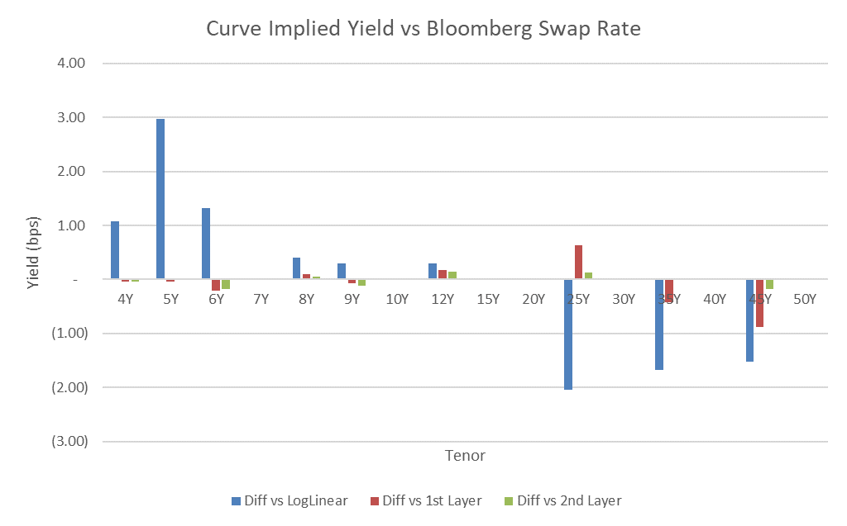

## Trading Ideas

### 5s10s30s Swap Fly

* Expected to make 5 million by trading this in a relative value set up.
* Average holding time: daily / weekly
* Current level: 9.31
* Target mean: 9

This is a macro theme trade that expresses view on the curvature of the yield curve. It shows a strong mean reverting behavior since 2022 January. By ADF test, we can reject the null hypothesis (time series is non-stationary) at 1% significance level. So it is highly likely that we are able to trade the RV of this structure.

Regression formula (value normalized):

$$5s10s30s=1.04*2s5s10s+0.754*10y+0.367*1m10y+residuals$$

By statistical model, we can see 5s10s30s can be expressed by a combination of 2s5s10s, 10y (market beta) and 1m10y norm vol (market scarcity). By the following regression results, we can see a high R-square and each independent variable is significant enough to explain the dependent variable.

Note the regression has 1m10y norm vol as a factor that represents the short-term driver of interest rate under the scenario “flight to quality”. As funds flee from risker assets, the sectors at the front end receive the greatest amount of flows, given their easy access for liquidity purpose. When market is negatively shocked by credit shortage, investor tends to buy short-term cash and pushes the yield lower. As a result, 5s10s30s will cheapen when market turns risk-off and we can see the positive correlation vs 1m10y.

Currently, the 3m roll down of 5s10s30s swap fly is 2.2bps, and carry is 0.7bps. But by the above plots, we can see the current residual is -0.41, which means 5s10s30s is rich in a relative value framework. Another consideration is the possible tightening of the belly spread in the future when credit getting better, which will richen the swap fly more. As a result, I am neutral to this structure at this moment, and will not build any positions.

### Short 10y Spread.

* Short belly spreads, i.e., 10y
* Average holding time: monthly
* Can express this view by selling 5s10s30s spread fly, currently at 34

|  |  |  |  |
| --- | --- | --- | --- |
|  | **Spread Drivers** | **My Current View** | **Prediction** |
| *Long Term Trends* | Banking System Credit | Much relieved after SVB, FRB and CS failure. The Banking aggregated CDS index has dropped 50% from the peak at 2023 March. | Tighten |
| Expected Future Budget Deficits | Currently Deficits % of GDP is 8.432% and see a declining trend till 2024 by CBO. The US Treasury ramped up debt issuance, heralding a supply deluge that’s likely to last several quarters | Tighten |
| Availability of Money/Liquidity | Expected the Fed loosen monetary policy in 2024 and adding money supply. The real funds rates has increased to 2.15%, which is highest since the Credit Crunch in 2008. Believe the rate will go lower, which indicating an easier monetary policy | Tighten |
| Pension Funds Matching Liability | High interest rates environment will last for years and Pension funds have to match the decreasing value of long-term liabilities. They tend to pay swaps due to simple and relatively liquid way to reduce exposure. This action will take years to fully manifest themselves. | Widen 30y spread |
| *Short Term Trends* | Mortgage Hedging | The 30-year fixed-rate mortgage averaged 7.23% in the week ending August 24, rising to their highest level since 2001. The ongoing economic strength and persistent high inflation may push mortgage rates higher. | Widen belly spread |
| Corporate Issuance | September usually has larger than usual corporate issuance. | Tighten |

The impact of the aggregated factors above on belly spreads will be a strong tightening force. As a result, I would short 10y spread with continuous evaluations on the factors listed above.

### SR3 vs SR1 Futures

* Expected to make 3mil on trading the discrepancy between SR1 and SR3
* Example: short SFRU3, long delta hedged SERU3, SERV3, SERX3 and SERZ3
* Average holding time: months

Front end curves can be calibrated using either SR1 or SR3, or a mixture of both adjusted by convexities and weights. However, the implied forward rate can be different from choosing which curvesets to calibrate. The discrepancy between SR3 and the overlapped SR1 may comes from liquidity, volatility or simply market mispricing.

Example: SFRU3 vs (SERU3, SERV3, SERX3, SERZ3)

Instead of the traditional regression model, we are using neutral network here to overcome:

1. Multi-collinearity between exogenous variables
2. Non-linear relationship between the prices of SR1 and SR3 because of stepwise forward

I have used the following hyperparameters in my MLP regressor:

$$MLPRegressor(hidden_{layer_{sizes}}=\left(10,\right), random_{state}=1,alpha=0.0001,activation=^{'}relu^{'},max_{iter}=10000)$$

The neutral network shows a prediction score at 0.999, which is high enough to trust.

By the above plots of the prediction residuals, we can see SFRU3 is rich compared to the SR1 futures for the past 2 months and also reached the YTD highest.

Assuming 0.5bps for transaction cost, the capacity of this arbitrage can be 1.5bps and 100k DV01. Ignoring the possible curve risk because of imperfect hedging, I am expecting to make 150k on this spread trade.

## What I Need

I am not really sure about what I really need. Just some random thoughts if nothing built yet.

* Assuming we have rudimental curve on SOFR, may need a Quant to help on get real time curve.
* E-trading platforms for quicker pricing and booking.
* Broker subscription to ICRV, ICAP and TRAD
* Real time risk monitoring interface to manage risk